AWS Backend Setup

Step 1 – Login in AWS Account.

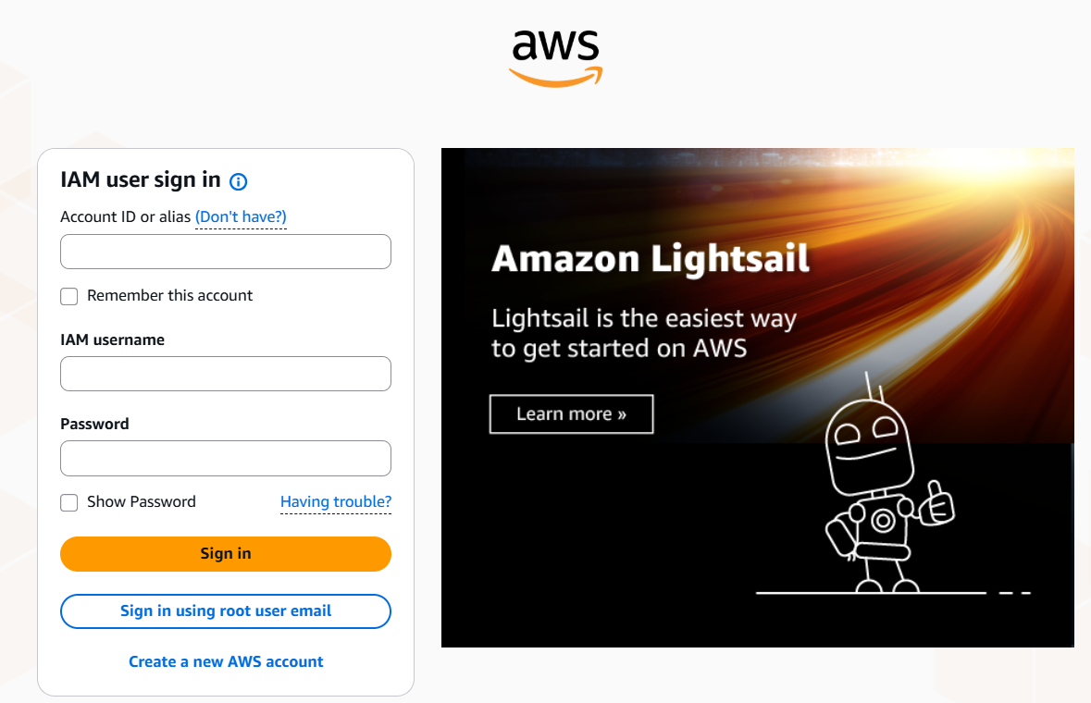

Step 2 – Launch EC2 Ubantu Server in the region you want and name it as “Backend-Master” instance type t3.micro

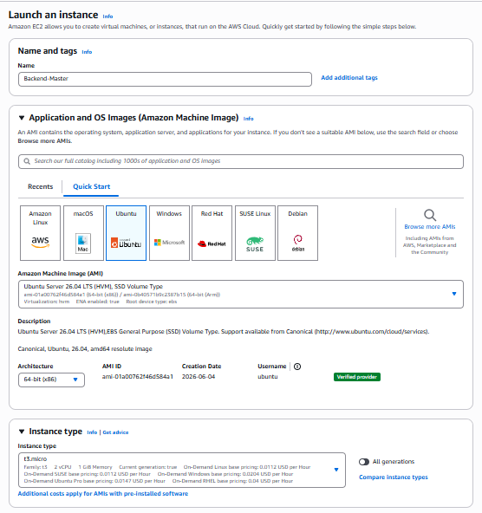

Step 3 – Now choose key pair and allow SSH , HTTP,HTTPS , with minimal storage and no file system .

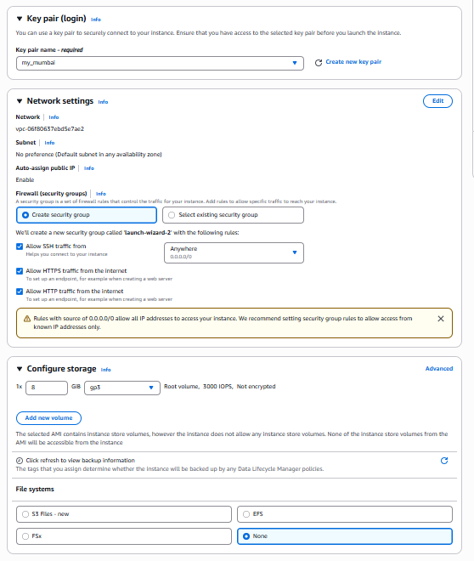

Step 4 – Go to Ec2 of Ubuntu name Backend-Master is running

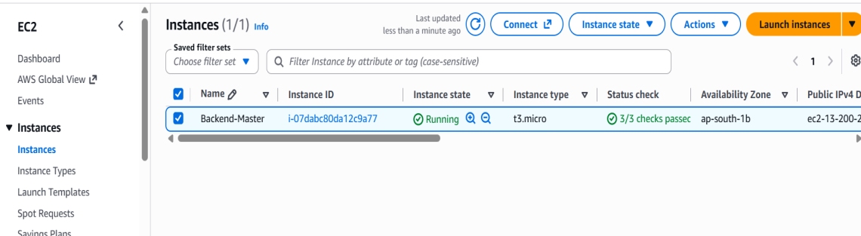

Step 5 - Open EC2 instance in browser now run following command.
sudo apt update

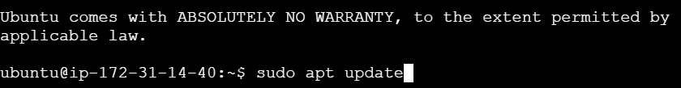

Step 6 – Open EC2 instance in browser now run following command.
sudo git clone https://github.com/UnpredictablePrashant/TravelMemory.git

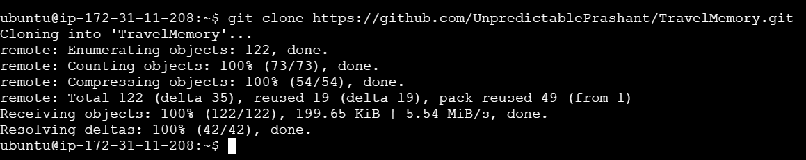

Step 7 – Now run the following command.
cd TravelMemory
cd backend

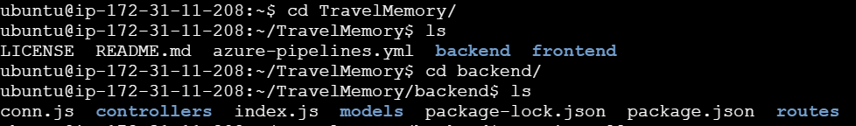

Step 8 - Now run the following command.
sudo apt install -y nodejs npm git nginx after installing check the version
npm –v & node –v

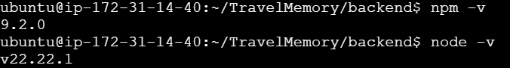

Step 9 - Now run the following command.
sudo npm install

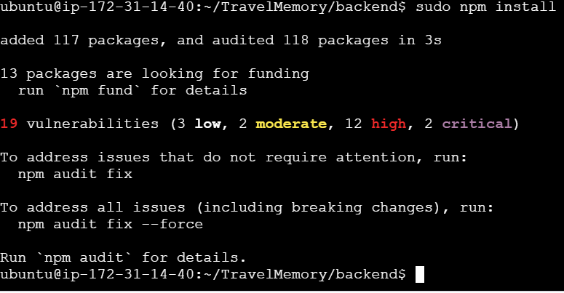

Step 10 – Now run the following command.
sudo nano .env and paste this command and replace the link which is there in MongoDB Compass application of your DB.

Step 11 – Now run the following command.
Go to EC2 – Security – Inbound rule and do the needful changes add rule in that choose custom TCP Range 3000 – 3001 and choose Anywhere IPV4 and save it.

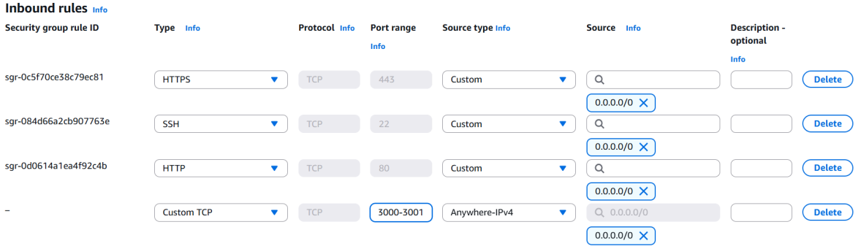

Step 12 - Now run the following command.
sudo node index.js

Step 13 – Now run the node index.js

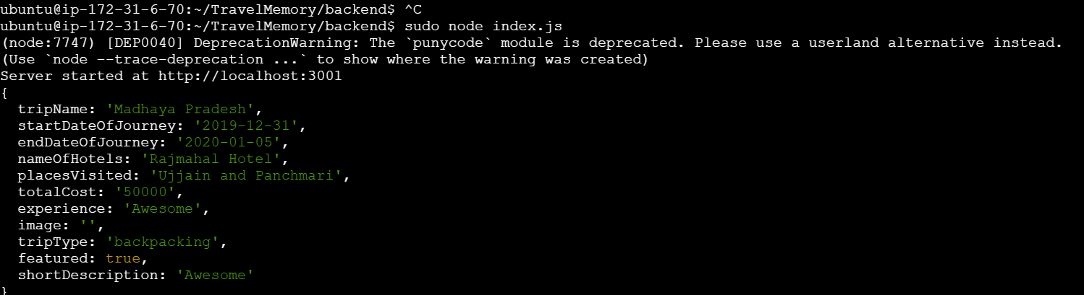

Step 14 – Go to browser and type your public ip colon 3001 and forward slash hello

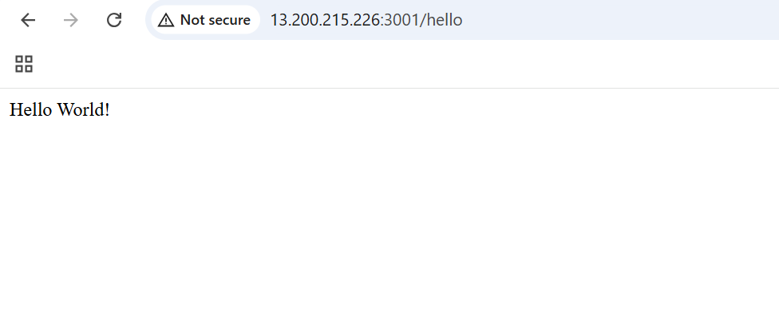

Step 15 – Select backend-master → Actions → Image and templates → Create image → name it travelmemory-backend-ami

Step 16 - Launch a new instance from travelmemory-backend-ami → backend-2.

